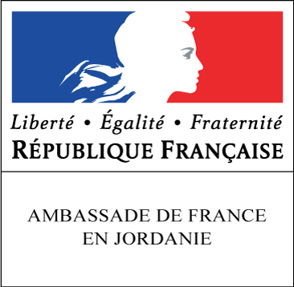
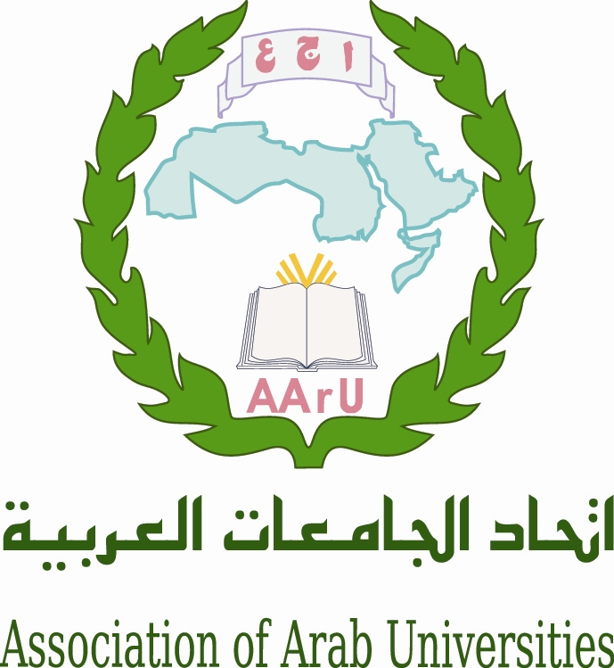
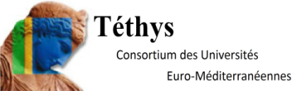

Governing Board Meeting of the Euro-Mediterranean Universities Network TETHYS

Association of Arab Universities

With the support of the Embassy of France

2nd of april 2015

STRENGTHENING of RELATIONS Between HIGHER EDUCATION
and the WIDER ECONOMIC and SOCIAL ENVIRONMENT

University-Enterprise Cooperation, Entrepreneurship and Employability of Graduates

Venue : Headquarter of the Association of Arab Universities, 11941 Jubeyha, Amman, Jordan

Programme

Thursday 2 april

8h30-9h00 Registration of participants

9h00-9h30 M. Sultan Abu-Orabi, Secretary General of the Association of Arab Universities
M. Michel Kasbarian, Honorary President of Tethys, Aix-Marseille University Representative
Mrs Caroline Dumas, Ambassador of France in Jordan

9h30-10h30 Workshop 1 : University-Enterprise Cooperation

Moderator : Mrs Lisbeth Ngouanet (Embassy of France in Amman)

Mrs Marie Odile Ott, (French Ministry IGAENER), “Making university-industry partnerships work: trials and lessons”

Dr. Maher Al-Mahrouq (Chamber of Industry), “universities-entreprises relationship”

10h30-11h00 Coffee break-Networking

11h00-12h30 University-Enterprise Cooperation - Entrepreneurship

Moderator: M. Mohamed Rafat Mahmoud (AArU)

M. Tarak Tabbaa (Amman Chamber of Commerce), “Practical ways and specificities”

M. Jean Louis Gouju (French Ministry Dir. Gén. Enseignement Supérieur et Insertion Professionnelle), “Different tools to strengthen relationship higher education and enterprises"

M. Adnan Badwan (Jordanian pharmaceutical Maufacturing Co) “Innovation as a sustaining strategy for the Jordanian pharmaceutical manufacturing company”

12h30-14h00 Lunch

14h00-16h45 Workshop 2 : Entrepreneurship - Employability of graduates

14h00-15h00 Moderator : M. Omar Hasan Bani Ahmad (Princess Sumaya University of Technology)

Mrs Marie Decroix-Taffet (Aix-Marseille University), “Boosting Employment thanks to Entrepreneurship Education?"

M. Antoine Hokayem (Saint Joseph University), “Links between graduates’ skills and employability”

15h00-15h15 Coffee break-Networking

15h15-16h45 Employability of graduates

Moderator : M. Michel Autric (Aix-Marseille University/TETHYS)

M. Boualem Saidani (University of Bejaïa), “L’Employabilité des diplômés algériens »

M. Mohamed Belhaj (University of Sfax), “New looks on the role of Tunisian universities on professional insertion of graduates”

Ms Zeineb Mazouz (University of Barcelona), “LINKING-MED-GULF project: a triangular”

M. Bouchaïb Mernari (University of Beni Mellal), “entrepreneuriat et transfert de technologie”

16h45-17h00 Conclusion and closing session

M. Michel Kasbarian (TETHYS/AMU)

M. Sultan Abu-Orabi (AArU), M. Mohamed Rafat Mahmoud (AArU)

