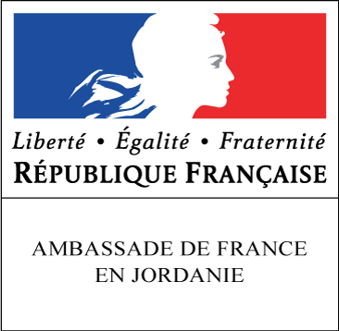
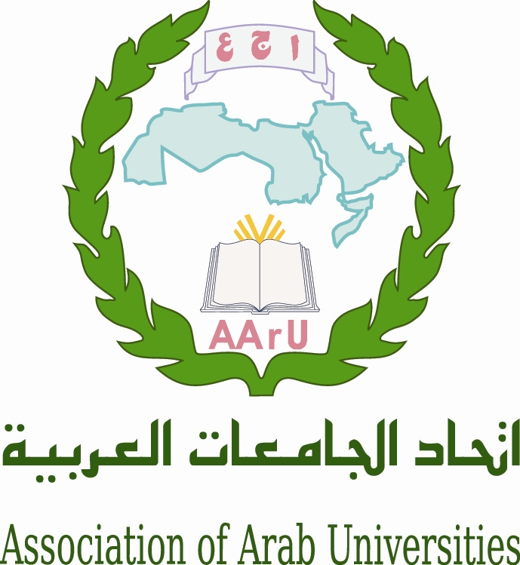
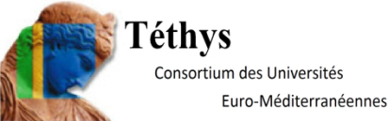

Governing Board Meeting of the Euro-Mediterranean Universities Network TETHYS

Association of Arab Universities

With the support of the Embassy of France

1st of april 2015

Venue : Headquarter of the Association of Arab Universities, 11941 Jubeyha, Amman, Jordan

Programme
Wednesday 1 april

12h00-13h00 Registration of Participants

13h00-14h00 Lunch

14h00-14h15 Welcome speeches

M. Sultan Abu-Orabi, Secretary General of Association of Arab Universities
M. Michel Kasbarian, Honorary President of Tethys, Aix-Marseille University

14h15-18h00 Governing Board meeting

Moderators: M. Rafat Mahmoud (AARU),
Mrs Giuseppina Nardo (Aix-Marseille University/Tethys)

14h15-14h45 Presentation of the Association of Arab Universities

14h45-15h45 Presentation of European Programmes and Strategy

M. Ahmad Abu-El-Haija, Director, National Erasmus + Office - Jordan
“The EU Erasmus + programme and its International Dimension in Higher Education ”

15h45-16h00 Coffee break

16h00-17h00 M. Michel Autric, Director TETHYS, Aix-Marseille University
TETHYS activities; Proposal for collaborations and new shares
M. Emilio Di Maria, University of Genova “multicentre collaborative project on telemedicine”
M. Mohamed Belhaj, University of Sfax “Technopark and entrepreneurship-Sfax”
Perspectives 2015/2016

17h00-17h45 Presentation/welcome of new partners
Mrs Ratiba Guidoum, Vice-Rector, University of Algiers 2
M. Bouchaïb Mernari, President, University of Beni Mellal

17h45-18h00 Candidate for next board 2015
Various questions; End of the Board

20h00 Gala Dinner hosted by AARU at the OCEAN RESTAURANT, Al-Madina Al-Munawarah Street, Amman

